RECENT DEVELOPEMENTS IN EUROPEAN LAW  WEBINAR SERIES | 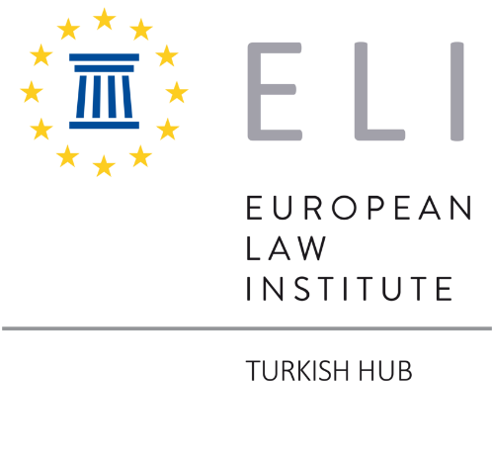

ELI Turkish Hub organizes a webinar series where current developments in European Law will be introduced to Turkish lawyers and the possible effects of these developments on Turkish law will be discussed. The first two meetings of this series will be held online and in Turkish on the following dates. The webinars are open to anyone who is interested in these topics.

Tuesday, 20 June 2023, 17:00-18:30 TR

EU Proposal on Recognition of Parenthood

Speakers: Ceyda Süral Efeçınar
Başak Başoğlu

Link to join the webinar.

Tueday, 18 July 2023, 17:00-18:30 TR

UNIDROIT Principles on Digital Assets and Private Law

Speakers: Kadir Berk Kapancı
Ekin Ömeroğlu

Link to join the webinar.

